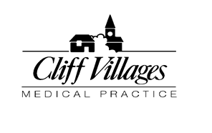

Dr. John McLoughlin
M.B., B.S., D.A., M.R.C.G.P.
GMC 3290325

Dr. Louise Beet
M.B., Ch.B., M.R.C.G.P., M.R.C.S., D.F.S.R.H., dlp. I.M.C.R.C.S. ed.

PATIENT CONSENT FORM

I …………………………………………. give consent for my …………………………………………….(relationship)
…………………………………………….(full name)
to have access to my medical records and for you to discuss my medical records with him/her.

Signed…………………………………

Dated…………………………………..

Print name………………………………………………..................

Date of birth..............................................................................

Address……………………………………………………………….……………………………………………………………………………………………………………………………………………………………………………………..Postcode…………………………….

Please provide below, a contact number for the person for whom you have given consent:

Home telephone……………………………………………………
Mobile telephone……………………………………………………

Grantham Road, Navenby, Lincoln LN5 0JJ. Tel: 01522 811411 Fax: 01522 813835

